*Quality charter of our partners:* ***:***

They have at least one of these certifications:

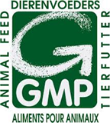 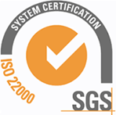

 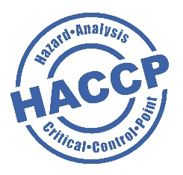

 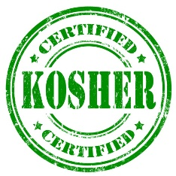

[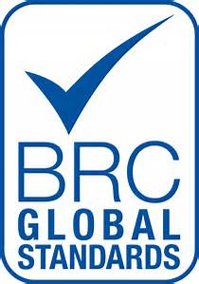](https://www.bing.com/images/search?q=BRC&view=detailv2&&id=70AC7E0584342D0FB5AB795B3E1CAF62468BF5EC&selectedIndex=0&ccid=7enoHpDv&simid=608022849085705039&thid=OIP.7enoHpDv8dnO4CgyuPQocgDSEs)